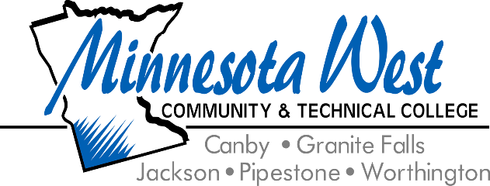

**September 30, 2024**

**For Immediate Release**

**Contact: Jackie Olson, Marketing Communications | 507-847-7931 | jackie.olson@mnwest.edu**

**Minnesota West Community and Technical College’s Surgical Technology Program Receives Continuing Accreditation**

Luverne, MN – Minnesota West Community and Technical College is proud to announce that its Surgical Technology Associate Degree program has received continuing accreditation from the Commission on Accreditation of Allied Health Education Programs (CAAHEP). This recognition is a testament to the program's commitment to excellence in education and healthcare.

The accreditation, granted on September 20, 2024, follows a rigorous evaluation process that assessed the program's curriculum, faculty, student outcomes, and compliance with industry standards. The next comprehensive evaluation and site visit is scheduled for no later than 2034, ensuring a decade of quality education for future surgical technologists.

“I am elated that the program received the full 10-year continuing accreditation. The program did a deep dive by evaluating the curriculum threads against the new standards. In this process, several changes were made to enhance the student learning outcomes and improve the curriculum delivery outline,” said Jackie Otkin, Dean of Allied Health of Minnesota West Community and Technical College. “This reaffirms the exceptional work of our faculty and staff and the dedication to preparing our students for successful careers in the healthcare field."

“Receiving full accreditation is another completed milestone for the Surgical Technology Program. The students, faculty, administration, and the advisory board members played an integral part in this accomplishment,” said Amy McCuen, Surgical Technology faculty member. “We look forward to helping our students perfect their surgical skills, graduate, pass their certification exam, and join the surgical teams in their communities.”

Minnesota West’s Surgical Technology program offers students a hands-on education that prepares them to work in operating rooms alongside surgeons, anesthesiologists, and nurses. Graduates of the program are equipped with the skills necessary to contribute to patient care and safety during surgical procedures.

For more information about the Surgical Technology program and other majors, visit [www.mnwest.edu](http://www.mnwest.edu) or contact the college at 800-658-2330.

Minnesota West Community and Technical College offers over 60 technical career and liberal arts majors on five southwest Minnesota campuses in Canby, Granite Falls, Jackson, Pipestone, and Worthington along with learning centers in Marshall and Luverne, MN. The College is a leader in distance learning and Internet delivery. Minnesota West is a member of the Minnesota State Colleges and Universities System. The largest provider of higher education in the state of Minnesota. Minnesota State is an affirmative action, equal opportunity employer and educator.