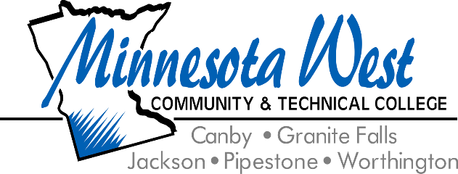

**September 25, 2024**

**For Immediate Release**

**Contact: Jackie Olson, Marketing Communications | 507-847-7931 | jackie.olson@mnwest.edu**

**Minnesota West Community & Technical College Receives $1.6 Million EDA Grant to Address Growing Demand for Skilled Manufacturing Workers**

September 25, 2024 – Minnesota West Community & Technical College was awarded $1.6 million by the U.S. Economic Development Administration (EDA) to enhance workforce training in robotics, fluid power, welding, electrical and mechanical systems across southwest Minnesota. This opportunity presented itself when Minnesota West partnered with the Upper Minnesota Valley Regional Development Commission to prepare and submittal an Economic Adjustment Assistance (FY23 EDA Disaster Supplemental) grant application.

The project will involve the upgrade of Minnesota West’s Mechatronics Lab and two Welding Labs as well as an enhancement of the customized welding trailer. This will expand workforce training capabilities at Minnesota West's campuses in Granite Falls, Jackson, and Worthington locations and also through the Customized Training programming demographics. The grant will bring state-of-the-art technology to students and local businesses, ensuring that communities across the region benefit from cutting-edge training programs. This investment could potentially create 250 jobs and leverage an additional $1 million in private investment, contributing to economic growth in the region.

“We are incredibly excited about this award, which will significantly enhance our ability to provide hands-on training in mechatronics and welding in our region,” said Arthur Brown, Provost of Minnesota West. “The acquisition of new equipment in areas like robotics, pneumatics, hydraulics, and welding will bring state-of-the-art technology to our campuses and even into our communities through a mobile welding trailer. This investment not only supports our mission to train skilled workers but also strengthens manufacturing and promotes economic growth across the region.”

Dr. Craig Peters, Dean of Management and Technical Programs went on to say, “The flexibility offered by the mobile classroom and trailer will allow Minnesota West to bring high-quality technical education directly to local communities and businesses, ensuring that the training responds directly to workforce needs. This grant provides Minnesota West with the opportunity to deliver a broad spectrum of training, from basic to advanced levels, across Southwest Minnesota. By collaborating with secondary schools and industry partners, we will offer educational resources in both English and Spanish. Additionally, this funding enables Minnesota West to enhance its curriculum, aligning with the needs of local industries as they transition to Industry 4.0."

Additional resources can be found at www.eda.gov and www.unvrdc.org.

<https://www.eda.gov/news/press-release/2024/06/25/us-department-commerce-invests-16-million-strengthen-manufacturing>

Minnesota West Community and Technical College offers over 60 technical career and liberal arts majors on five southwest Minnesota campuses in Canby, Granite Falls, Jackson, Pipestone, and Worthington along with learning centers in Marshall and Luverne, MN. The College is a leader in distance learning and Internet delivery. Minnesota West is a member of the Minnesota State Colleges and Universities System. The largest provider of higher education in the state of Minnesota. Minnesota State is an affirmative action, equal opportunity employer and educator.