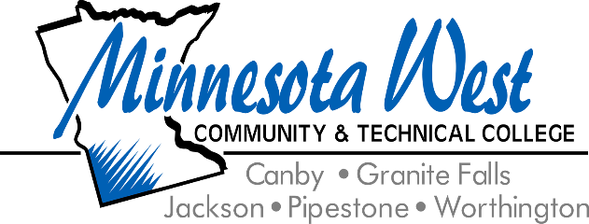

**September 25, 2024**

**For Immediate Release**

**Contact: Jackie Olson, Marketing Communications | 507-847-7931 | jackie.olson@mnwest.edu**

**Minnesota West Expands Online Enrollment to Students in 49 States Through Participation in NC-SARA**

Minnesota West is excited to announce that, effective September 22, 2024, the college has been approved to participate in State Authorization Reciprocity Agreements (SARA) by Minnesota’s SARA State Portal Entity, allowing us to offer distance education programs to students in other SARA member states. This opportunity allows Minnesota West to expand our educational offerings and assures our adherence to quality assurance and student consumer protections.

SARA participation is determined by each institution’s home state and supported by the country’s four regional higher education compacts (MHEC, NEBHE, SREB, and WICHE) and the National Council for State Authorization Reciprocity Agreements (NC-SARA). SARA is a voluntary, interstate reciprocal approach to state oversight of postsecondary distance education with a mission to promote high-quality distance education and ensure regulatory compliance across state lines. By participating in NC-SARA, Minnesota West is proud to guarantee the quality and accessibility of its online programs while opening the doors to students from across the country.

“As a college deeply rooted in Southwest Minnesota, we are excited to expand our reach through SARA participation. This approval allows us to connect with students beyond our region while maintaining our strong commitment to the communities we serve locally. By participating in SARA, we ensure that all students—near or far—receive the same high-quality education and support that define Minnesota West,” stated Dr. Arthur Brown, Provost.

NC-SARA makes it simpler for students to take online courses from out-of-state institutions while ensuring consistent academic standards. With this membership, Minnesota West is approved to provide online education to students in nearly any state across the U.S., expanding opportunities for learners seeking to pursue their academic goals through distance learning.

For more information on NC-SARA, including a national map, a list of participating states, and member institutions, please visit the NC-SARA website.

Minnesota West remains committed to enhancing the quality of its online education programs and ensuring students receive the support and resources needed to succeed in today’s rapidly changing educational landscape.

Minnesota West Community and Technical College offers over 60 technical career and liberal arts majors on five southwest Minnesota campuses in Canby, Granite Falls, Jackson, Pipestone, and Worthington along with learning centers in Marshall and Luverne, MN. The College is a leader in distance learning and Internet delivery. Minnesota West is a member of the Minnesota State Colleges and Universities System. The largest provider of higher education in the state of Minnesota. Minnesota State is an affirmative action, equal opportunity employer and educator.