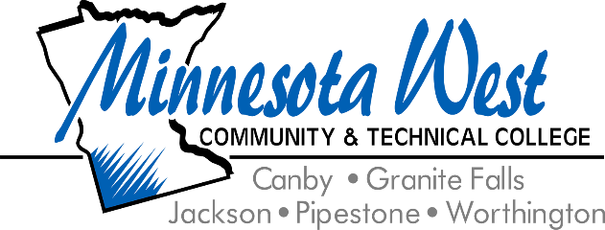

**September 25, 2024**

**For Immediate Release**

**Contact: Jackie Olson, Marketing Communications | 507-847-7931 | jackie.olson@mnwest.edu**

**Dean of Student Services & Enrollment Appointed to Upper Minnesota Valley Regional Development Commission Board**

Minnesota West Community & Technical College is pleased to announce that Rebecca Weber, Dean of Student Services & Enrollment, has been appointed as a board member of the Upper Minnesota Valley Regional Development Commission (UMVRDC). In this new role, she will bring her extensive experience in education and community involvement to support regional development efforts.

A native of Madison, Weber has been a vital part of Minnesota West for 25 years. Her tenure at the college has spanned roles in admissions, marketing, counseling, and teaching, giving her a deep understanding of the needs of students and communities alike. She has also earned the distinction of Outstanding Academic and Student Affairs Administrator from the Minnesota State Colleges and Universities System.

Dean Weber's involvement with her local community extends beyond her role at the college. She is a member of the Canby Rotary, Canby Chamber, St. Michael’s Catholic Church, Luoma Leadership Academy, and several work groups. Her energy and commitment to community success align perfectly with the mission of UMVRDC, which is dedicated to fostering economic, social, and physical development in the region.

"We are proud of Dean Weber for her new role on the UMVRDC Board. Her dedication to Minnesota West and the broader community over the past 25 years makes her an ideal representative. She will bring the same level of excellence to her new role. We congratulate her and look forward to the positive impact she will continue to make." – Terry Gaalswyk, President, and Arthur Brown, Provost, Minnesota West Community & Technical College

The UMVRDC, which celebrated its 50th anniversary in 2023, has been a key player in supporting local government units across the region. Its programs include energy planning, economic development, and initiatives to improve public safety and health. The commission also facilitates the Revolving Loan Fund, which provides GAP financing to small businesses, ensuring their continued service to the community.

As Dean Weber takes on this new role, she looks forward to collaborating with UMVRDC partners on exciting projects like the "lunch and learn" program, which focuses on youth career and training opportunities in the area.

Dean Weber's leadership is a reflection of the partnership between Minnesota West Community & Technical College and the regional development initiatives shaping the future of greater Minnesota.

Minnesota West Community and Technical College offers over 60 technical career and liberal arts majors on five southwest Minnesota campuses in Canby, Granite Falls, Jackson, Pipestone, and Worthington along with learning centers in Marshall and Luverne, MN. The College is a leader in distance learning and Internet delivery. Minnesota West is a member of the Minnesota State Colleges and Universities System. The largest provider of higher education in the state of Minnesota. Minnesota State is an affirmative action, equal opportunity employer and educator.